CodeWarrior for HCS12 C Programming

Updated 08-17-10 by: M. Mazidi with contribution from Travis Chandler and Danny Causey
- Start CodeWarrior for HCS12 and click Crate New Project shown below.
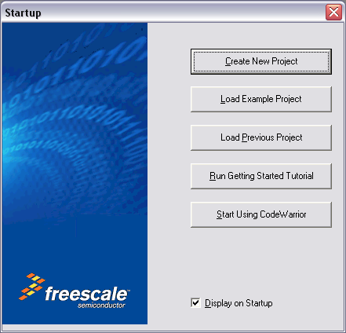

**If CodeWarrior is already running you may select new project from the file menu or click the icon on the tool bar.
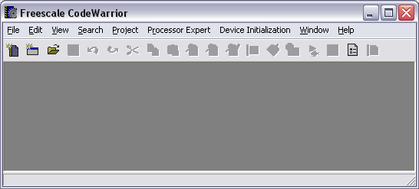

- Select the MCU to program and your connections. You can change your connection at any time after creating a project, for now we choose full chip simulation. Click Next.
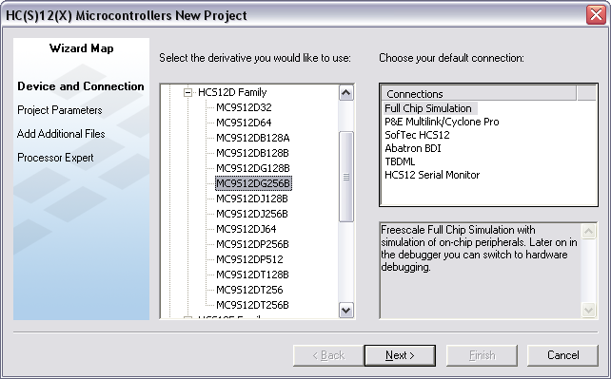

- Set the location where the project is to be saved, and name the project as shown below. Choose the language(s) you will be using. Click Next.
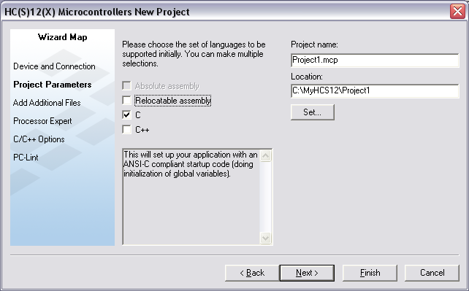

- Choose any files your project will use, for this example we do not need any additional files. Click Next.
**You can also add files to your project after it has been created.
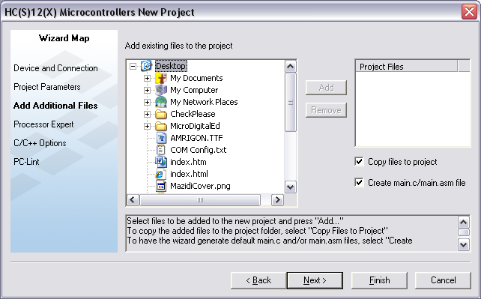

- Choose ‘None’ for Rapid Application Development. Click Finish.
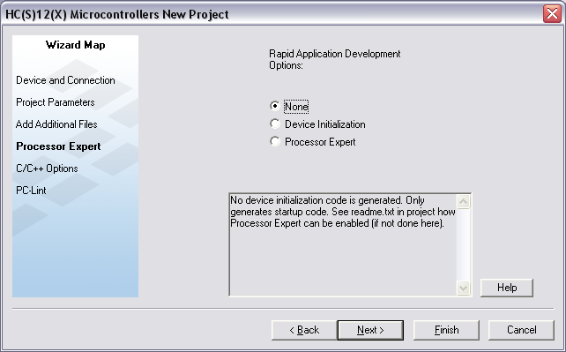

- Choose the following start up options, Click Next:
  - minimal startup code
  - Small memory model
  - None, floating point support
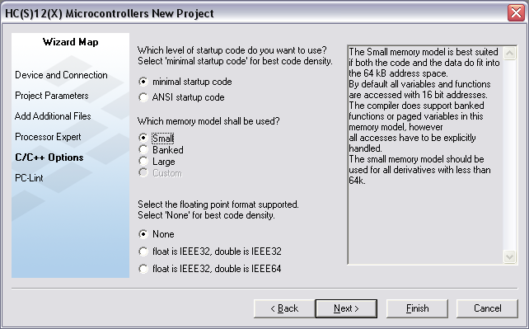

- Select No for PC-Lint. Click Finish.
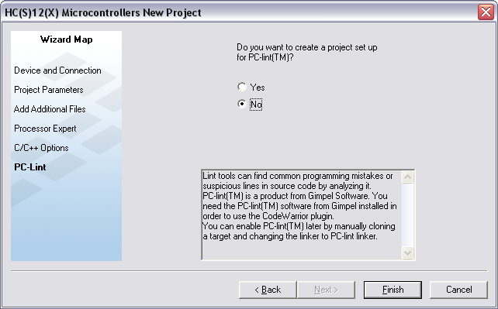

- Expand the Sources folder created by CodeWarrior and double click main.c as shown below. CodeWarrior provides a template to begin the program, see the full template below the graphic.
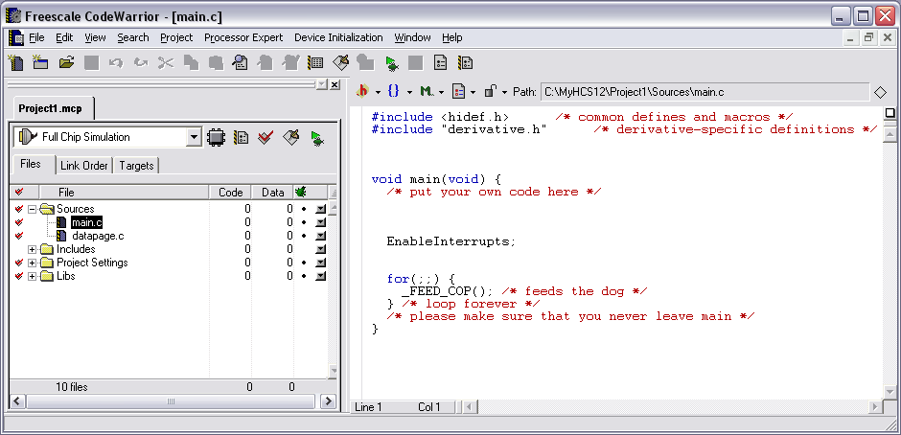

#include <hidef.h> /* common defines and macros */
#include "derivative.h" /* derivative-specific definitions */
#pragma LINK_INFO DERIVATIVE "mc9s12dp512"
void main(void) {
/* put your own code here */
EnableInterrupts;
for(;;) {
_FEED_COP(); /* feeds the dog */
} /* loop forever */
/* please make sure that you never leave main */
}

- Replace the template code with an example from the book as shown below or your own code. Note that the minimal requirements for a C program are the header file, that defines the registers of the MCU, and the function void main(void) {…} with a blocking function at the bottom or the program should be an infinite loop.
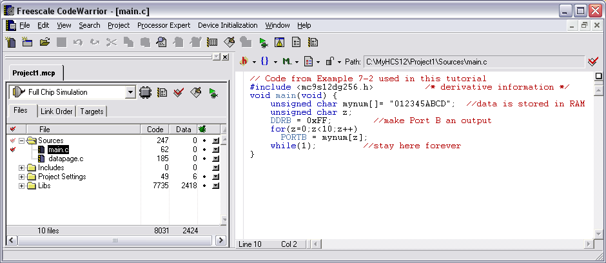

// Code from Example 7-2 used in this tutorial
#include <mc9s12dg256.h> /* derivative information */
void main(void) {
unsigned char mynum[]= "012345ABCD"; //data is stored in RAM
unsigned char z;
DDRB = 0xFF; //make Port B an output
for(z=0;z<10;z++)
PORTB = mynum[z];
while(1); //stay here forever
}

- Full Chip Simulation should be selected in the drop down box, Under Project Click Make (F7) and then Click Debug (F5). (or use the Make and Debug icons as shown here).
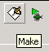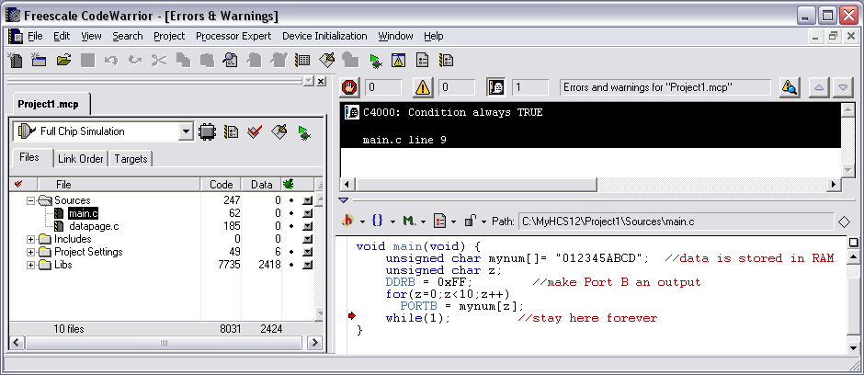

**CW will advise you that you have a conditional statement that is always true.

If this is confusing, you can delete everything in the main.c program in the CodeWarrior. Then go to the www.MicroDigitalEd.com web site and under HCS12 book click on “Dragon12 Sample Programs and Support”. You will see sample programs in both Assembly and C for Dragon12 plus Trainer board. In the C program section Click on “Toggling LEDs on PORTB”. Copy the program and paste it into the main.c program.

11) After clicking F5 (Debug) CodeWarrior will give you “True Time Simulator & Real Time Debugger” screen. Use F11 to single step through the program or use blue icons to debug the program. To examine the contents of memory locations click on Memory window and you will see Memory at the top ( next to Component). Click on Memory and drop-down menu gives you the options. See the Debug Tutorial for details.

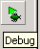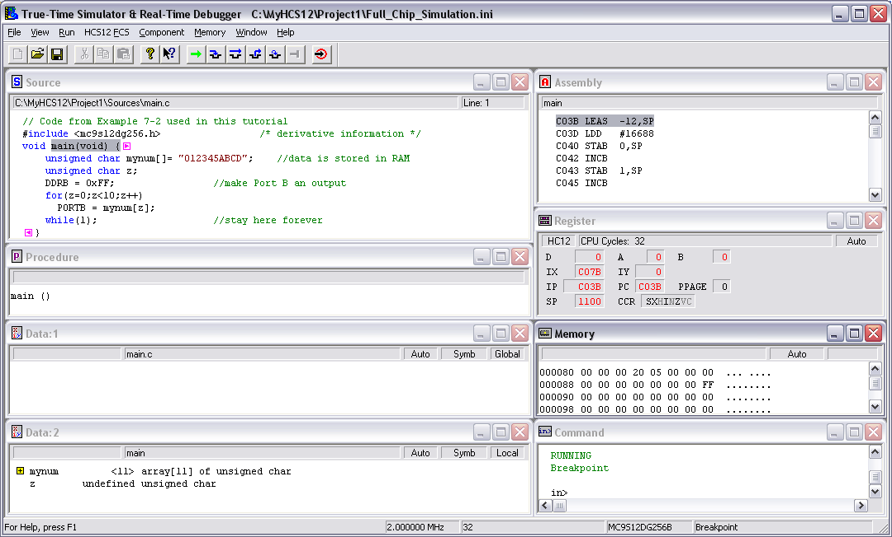

12) Compiling, Downloading and Executing a program for Dragon12 Plus Trainer board (or any trainer board). Now, close the True-Time Simulation window. Delete everything in the main.c program in the CodeWarrior. Go to the www.MicroDigitalEd.com web site and under HCS12 book click on “Dragon12 Sample Programs and Support”. You will see sample programs in both Assembly and C for Dragon12 plus Trainer board. In the C program section Click on “Toggling LEDs on PORTB”. Copy the program and paste it into the main.c program

13) In the drop-down where it shows Full Chip Simulation choose HCS12 Serial Monitor. Connect your Dragon12 board to the x86 PC USB port and power up the board. Press RESET button. Then Press F7 (make), F5 (Debug) to Download (make sure you choose the right COM port), and F5 (run) to execute the program. You will see the LEDs toggle on and off.
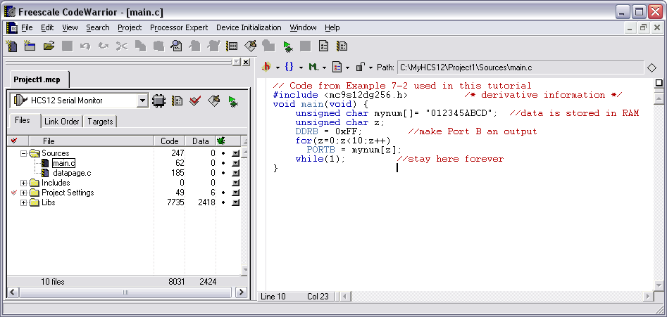

14) Always close the True-time Simulation window, RESET the board, and make sure you are in HCS12 Serial Monitor mode before you download and execute any program.

