CodeWarrior for HCS12 Assembly Programming
Updated 08-17-10 by: M. Mazidi with contribution from Danny Causey and Travis Chandler
- Start CodeWarrior for HCS12 and click Crate New Project shown below.
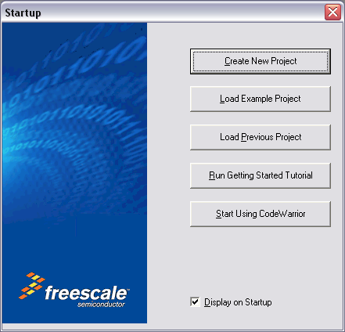

**If CodeWarrior is already running you may select new project from the file menu or click the icon on the tool bar.
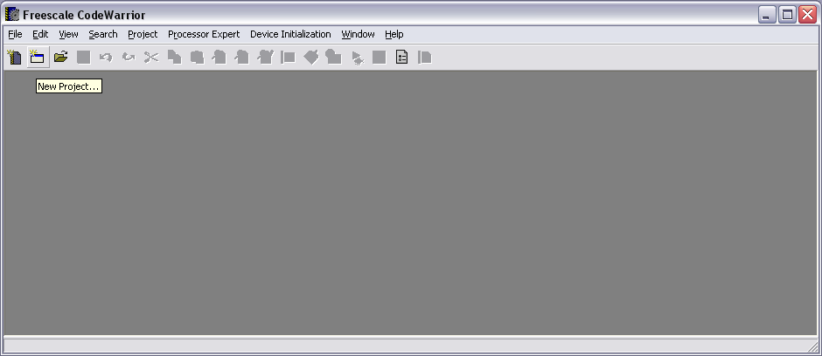

- Select the MCU to program and your connections. You can change your connection at any time after creating a project, for now we choose full chip simulation. Click Next.
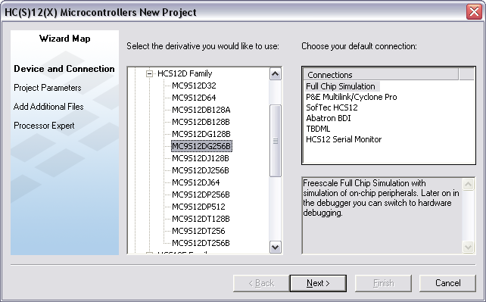

- Set the location where the project is to be saved, and name the project as shown below. Choose the language(s) you will be using. Unselect the “Relocatable assembly” then select “Absolute assembly”. Click Next.
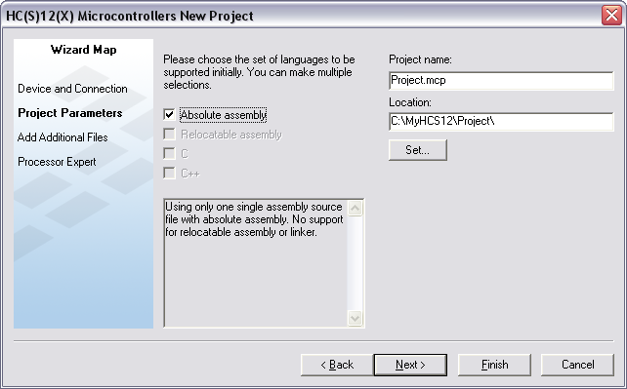

- Choose any files your project will use, for this example we do not need any additional files. Click Next.
**You can also add files to your project after it has been created.
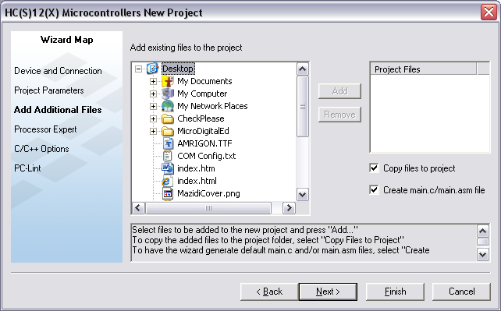

- Choose ‘None’ for Rapid Application Development. Click Finish.
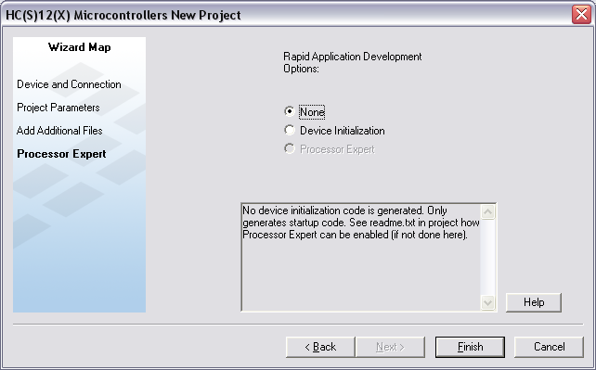

- Expand the Sources folder created by CodeWarrior and double click main.asm as shown below.
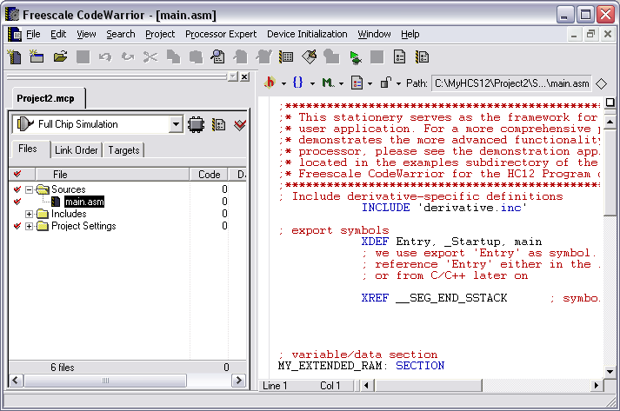

- Replace the template code provided by CodeWarrior with an example from the book as shown below or your own code. Note that the minimal requirements for an Assembly program are the following:
a) the ABSENTRY Entry declaration at the top.
b) the include file that defines the registers of the MCU
c) the ORG declaration above the Entry label and
d) the ORG $FFFE and DS.W Entry declaration below the program.
Also note that the book does not define Assembly code this way. This is for compatibility with a variety of Assemblers for the HCS12. See the full code defined for CodeWarrior below the graphic. You can use the code as template for examples in the book by replacing the code between Entry: and END.
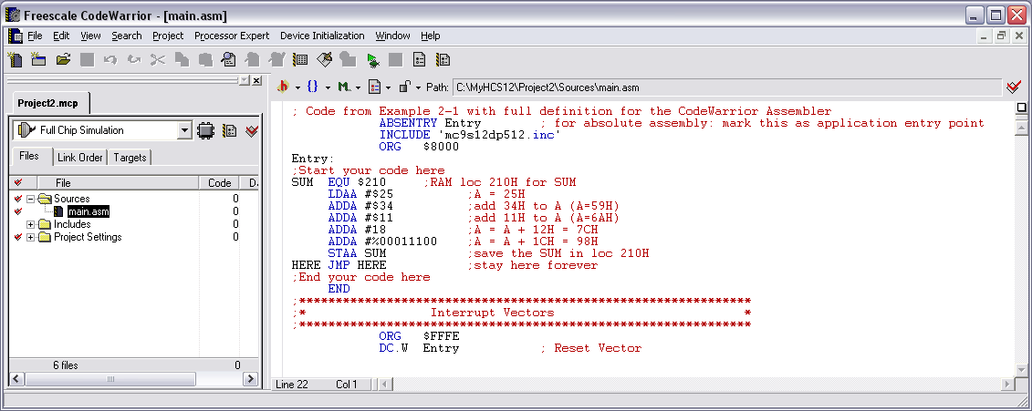
If this is confusing, you can delete everything in the main.asm program in the CodeWarrior. Then go to the www.MicroDigitalEd.com web site and under HCS12 book click on “Dragon12 Sample Programs and Support”. You will see sample programs in both Assembly and C for Dragon12 plus Trainer board. In the Assembly program section Click on “Toggling LEDs on PORTB”. Copy the program and paste it into the main.asm program.

- Full Chip Simulation should be selected in the drop down box, Click Make icon (F7) Click Debug (F5). See the Debug Tutorial for details.
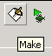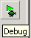

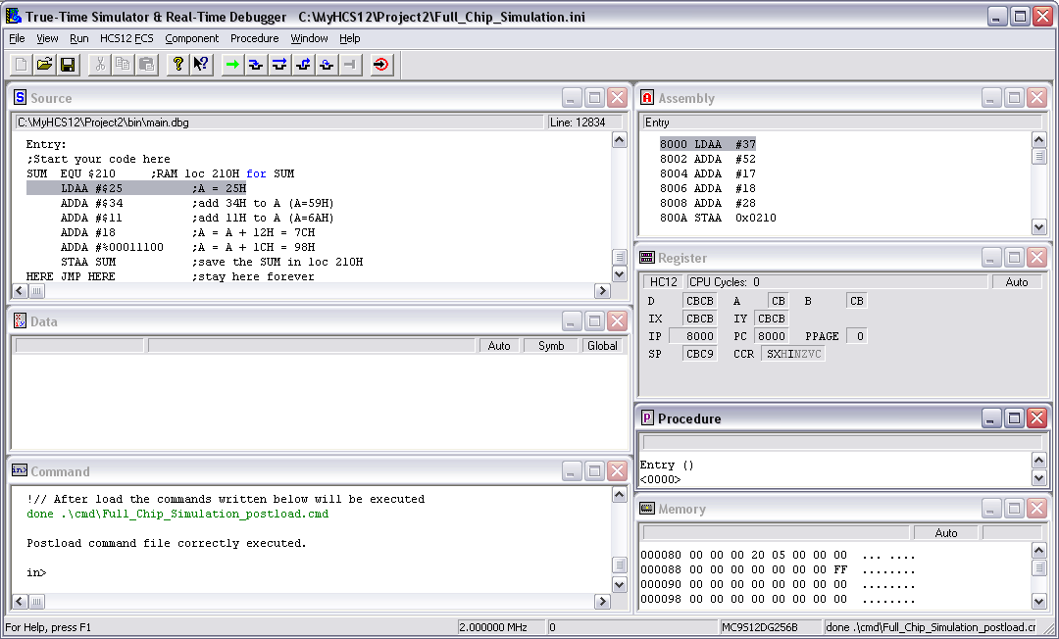

9) After clicking F5 (Debug) CodeWarrior will give you “True Time Simulator & Real Time Debugger” screen. Use F11 to single step through the program or use blue icons to debug the program. To examine the contents of memory locations click on Memory window and you will see Memory at the top ( next to Component). Click on Memory and drop-down menu gives you the options. See the Debug Tutorial for details.

10) Compiling, Downloading and Executing a program for Dragon12 Plus Trainer board (or any trainer board). Now, close the True-Time Simulation window. Delete everything in the main.asm program in the CodeWarrior. Go to the www.MicroDigitalEd.com web site and under HCS12 book click on “Dragon12 Sample Programs and Support”. You will see sample programs in both Assembly and C for Dragon12 plus Trainer board. In the Assembly program section Click on “Toggling LEDs on PORTB”. Copy the program and paste it into the main.asm program

11) In the drop-down where it shows Full Chip Simulation choose HCS12 Serial Monitor. Connect your Dragon12 board to the x86 PC USB port and power up the board. Press the RESET button. Then Press F7 (make), F5 (Debug) to Download (make sure you choose the right COM port), and F5 (run) to execute the program. You will see the LEDs toggle on and off.
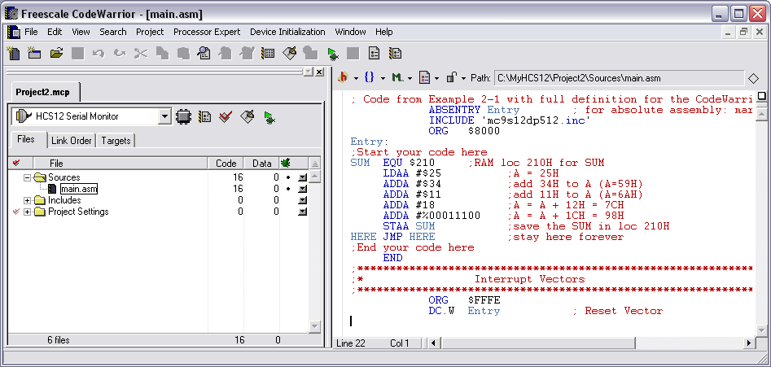

12) Always close the True-time Simulation window, RESET the board, and make sure you are in HCS12 Serial Monitor mode before you download and execute any program.

